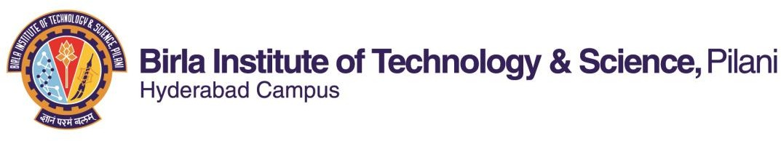

**SECOND SEMESTER 2021-2022**

**Course Handout (Part-II)**

# 15-1-2022

In addition to part-I (General Handout for all courses appended to the timetable) this portion gives further specific details regarding the course.

Course No. : **BIOT F422**

Course Title : **Introduction to Nanobiotechnology**

Instructor/s : **Suman Kapur**

***Course Description***: Introduction; Nanoscience in Nature; Fundamental science behind nanomaterials; Synthesis and properties of nanomaterials; Tools to study the properties, Size and Shape determinations, Application of nanomaterials in Science, Engineering and biomedical field; Future Trends in the field.

***Scope & Objectives***: This is a course for the science and engineering students to introduce the concept of Nanobiotechnology at a basic level. It shows that nanomaterials are there in nature in abundance. Proper appreciation and unfolding of them can lead to various fruitful application in Sciences, as well as in Engineering and Biomedical fields. The various techniques (conventional and modern) to synthesize and study nanomaterials are also covered. The course ends with discussion on direction towards which the field of Nanobiotechnology is growing at the moment with wide-spanning applications

**Text Book**: 1. Nicolini, Claudio, *Nanobiotechnology and nanobiosciences -- 2009*, World Scientific Pub

**Reference:** 1. C. M. Niemeyer and Chad A. Mirkin, *Nanobiotechnology: concepts, applications*

**Books** *and perspectives applications and perspectives*, *2004*, Wiley India

1. Balaji, Subbiah, *Nanobiotechnology, 2010,* MJ Publisher India
2. Khopkar, S. M., Instrumental methods in bioanalytical Chemistry

# Learning Outcomes:

The students will learn about but not limited to

1. Definitions as applicable to Nanoparticles and Nano structures
2. Laws of Physics and chemistry that govern the properties of nanostructures
3. Techniques used to characterize nanostructures
4. Methods used for synthesizing nanostructures
5. Properties of different nano materials
6. Applications of nanoscience in various fields like Biological research, Pharmacy and therapeutics, Medical Sciences and diagnostics, Electronics, Computer Science, Sustainable manufacturing, Synthesis of new materials with designer characteristics and applications of nanopolymers
7. Recent advances in the field of nanoscience

# Lecture Plan:

Note: Discussion on each topic spans across several chapters of the text book & reference books

|  |  |  |
| --- | --- | --- |
| Lecture No. | Learning Objectives | Topics to be covered |
| 1-2 | Introduction | What is Nanoscience? Where and how does the size  matter? Moore’s Law, Nanoscience in nature |
| 3-9 | Some Basics of Solid  State Physics & Quantum Mechanics | Lattice Structure, Band Diagram, Density of States at various dimensions |
| 9-16 | Fabrication of Nano- particles, Quantum  wells, wires and dots | Top-down and bottom up approach |
| 17-26 | Characterization and  Analysis | Scanning Tunneling microscopy, Scanning Probe  Microscopy, X-ray & Neutron Scattering Techniques |
| 27-32 | Properties of different  Nanomaterials | Thermo-mechanical, Optical, Electrical, Magnetic  Properties |
| 32-38 | Application of nano-  science in various fields | Molecular Electronics, Nanostructured materials,  Polymer nanocomposites, Nanobiology |
| 39-40 | Future Trends | Future Scope of Nanoscience and a step forward to a  more powerful Nanotechnology |

## Evaluation Scheme:

|  |  |  |  |  |  |
| --- | --- | --- | --- | --- | --- |
| EC  No. | Evaluation  Component. | Duration | Weightage | Date, Time  & Venue. | Nature of Component. |
| 1 | Mid Sem Test | 90 min. | 35% | 16/03 11.00am to12.30pm | Closed Book |
| 4 | 3 Seminars + 3  assignments | 3x5=15  3x5=15 | 30% | During class  hours | Open Book |
| 5 | Comprehensive  Examination | 2 hours | 35% | 19/05 AN | Closed Book+ Open  book |

*OB: Open book; CB: Closed book

## Grading policy:

Award of grades will be guided in general by the histogram of marks. Decision on border line cases will be taken based on individual’s sincerity, student’s regularity in attending classes and the instructor’s assessment of the student.

## Make-up policy:

Make-up for Mid semester examination will be given only in medical emergency cases of absence. If the absence is anticipated, before the examination, prior permission of the instructor-in-charge is necessary. Request for make-up should reach the instructor-in-charge at the earliest. Make-up for class tests/ quizzes and assignments are not permitted. Refer to Clause 4.07 of BITS Academic Regulations for more details.

***Chamber Consultation Hour****:* To be announced in the class.

***Notices****:* Notices concerning the course will be put up on the notice board of Department of Biological Sciences

***Academic Honesty and Integrity Policy***: Academic honesty and integrity are to be maintained by all the students throughout the semester and no type of academic dishonesty is acceptable.

Instructor-in-charge BIO F422